EXP NO 6: CREATE A SIMPLE CLOUD SOFTWARE APPLICATION FOR PRODUCT SELLING USING ANY CLOUD SERVICE PROVIDER TO DEMONSTRATE SAAS.

AIM: To create a simple cloud software application for product selling using any cloud service provider to demonstrate Saas.

PROCEDURE:
Step1: Go To Zoho.Com.
Step 2: Log Into The Zoho.Com.
Step 3: Select One Application Step.
Step4: Enter Application Name As Product Selling.
Step 5: Created New Application As Product Selling.
Step 6: Select One Form
Step 7: The Software Has Been Created.

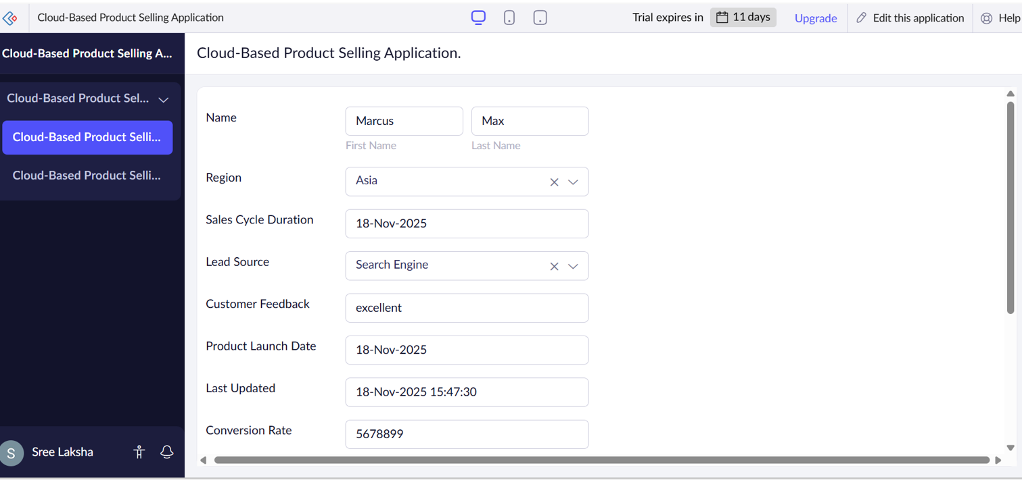
IMPLEMENTATION:

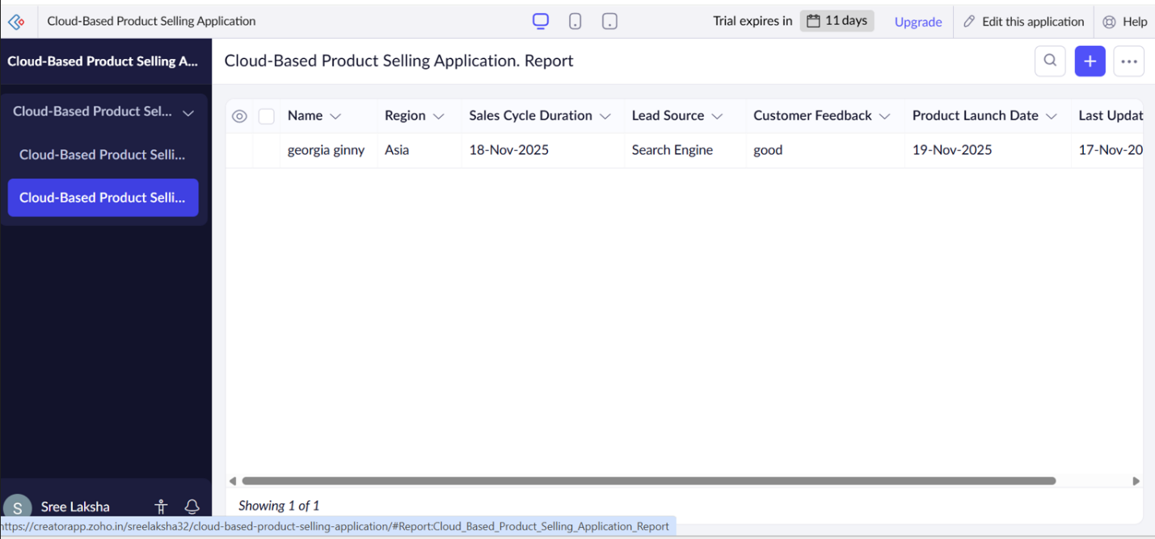
OUTPUT:

RESULT:
Thus a simple cloud software application for product selling using any cloud service provider to demonstrate saas was done successfully.

